***Workflow Keywords and Definitions***

**Nodes:** Nodes represent the stages the record type goes through and are the back-bone of workflows. Think of them as steps in the workflow process.

There are 6 types of nodes: Start, Unknown, Wait, Task, Condition, and End.

**Start:** Every workflow must begin with a Start node. This is the only time that this type of node is used. 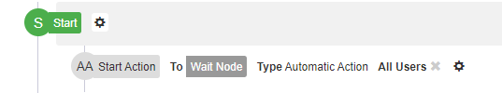

**Unknown:** The least common node style(usually not used); the Unknown node is used to keep a node position in case you do not know what type of node you would like to use yet and a fall back if a node for some reason is not recognized.



**Wait:** The most common node style, the Wait node is great for keeping the Workflow active while waiting for user actions or conditions to be met.



**Condition:** Like a Wait node, but meant to direct or split the workflow as opposed to waiting for actions to be taken. Alternatively, you can use a condition node as a “splitter” which will let the workflow branch off in multiple directions at the same time allowing multiple steps to be accomplish at the same time.



**Task:** Task nodes create and assign tasks (Activities) and wait for users to complete them. Whenever an action is taken (automatic or user) and they leave this node, the task will be marked as complete. Task nodes require an assigned user or group of users. This will control which users will see the task on their to-do list and which users will see the actions to take. 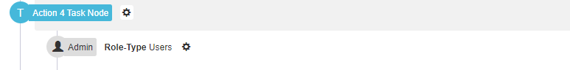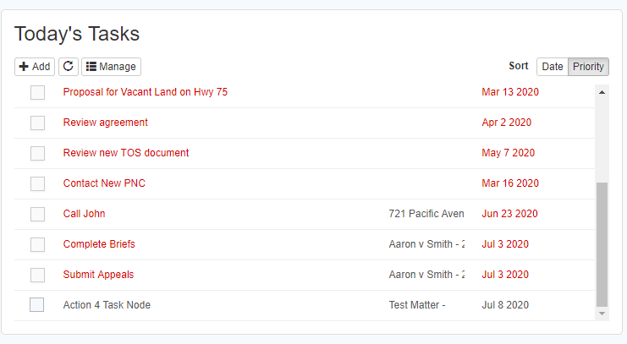

**End:** The End node ends the workflow and detaches the record type from the workflow. These can be used to end the current workflow and automatically start another. End nodes are more common in Triggers where an action is completed and the Trigger ends. In Workflows, sometimes you will leave the record on a Wait node as user actions can be created to loop through the workflow again or put an end node if its steps through a workflow.

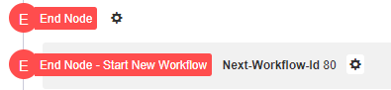

**Actions:** Actions are used to direct the workflow; this is what is used to move from node to node.

There are 2 types of: User Action and Automatic Action

**User Action (UA):** This action is manual, this will prompt a user to input or review information before moving forward.



**Action Forms:** This action can only be used with a UA; this will prompt the user with text boxes to fill in based on the fields selected.

 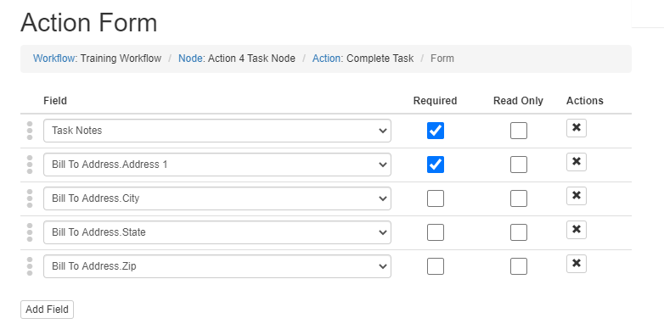

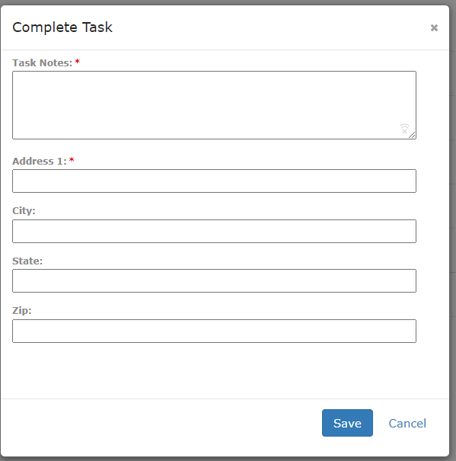

**Automatic Actions (AA):** This action is automated; this will not prompt the user anything and will look at certain criteria before moving forward. Things it will look at are a query prior to moving forward, if there is not one set it moves forward as soon as it enters the node.

  


**Commands:** Commands makes stuff happen when an action is done.

There are 5 types of commands: Create, Update, Email, Custom Code, and Mail Merge

**Create:** Create commands are used to create a new record of any type and link it to the main record.

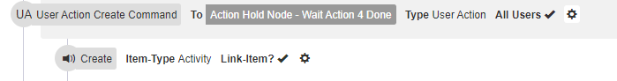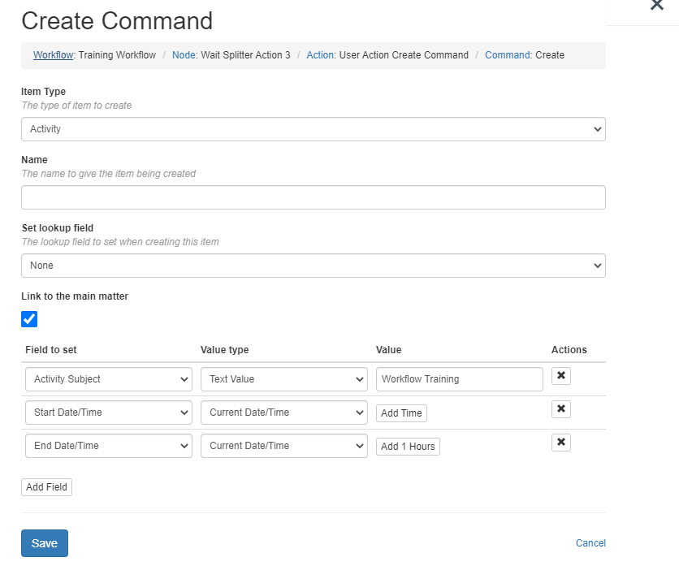

**Update:** Update commands are used to update fields within any record available through a lookup field, a lookup is any field that is linked to another record type such as Client (this is linked to a client record).

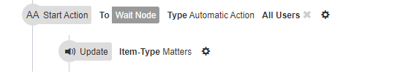

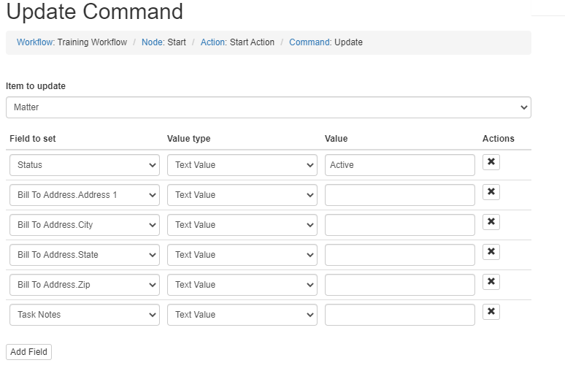

**Email:**  Email commands are used to send an email base on a template setup prior, these can be manually entered or can be based on a field on the record type.

I.E. you can use the primary client email address. So it works on all clients instead of just one that was manually entered

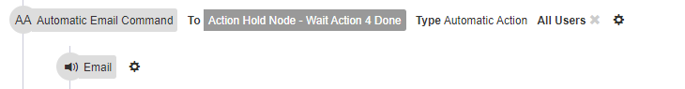

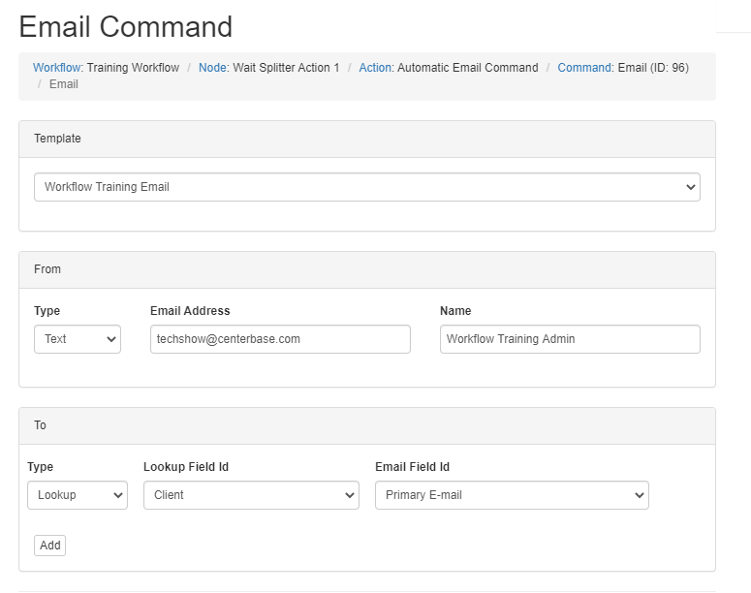

**Custom Code:** This is currently only used by Centerbase; it allows us to run custom codes

**Mail Merge:** Mail Merge commands are used to generate a document based on pre-defined word templates that can be linked to the record type.

